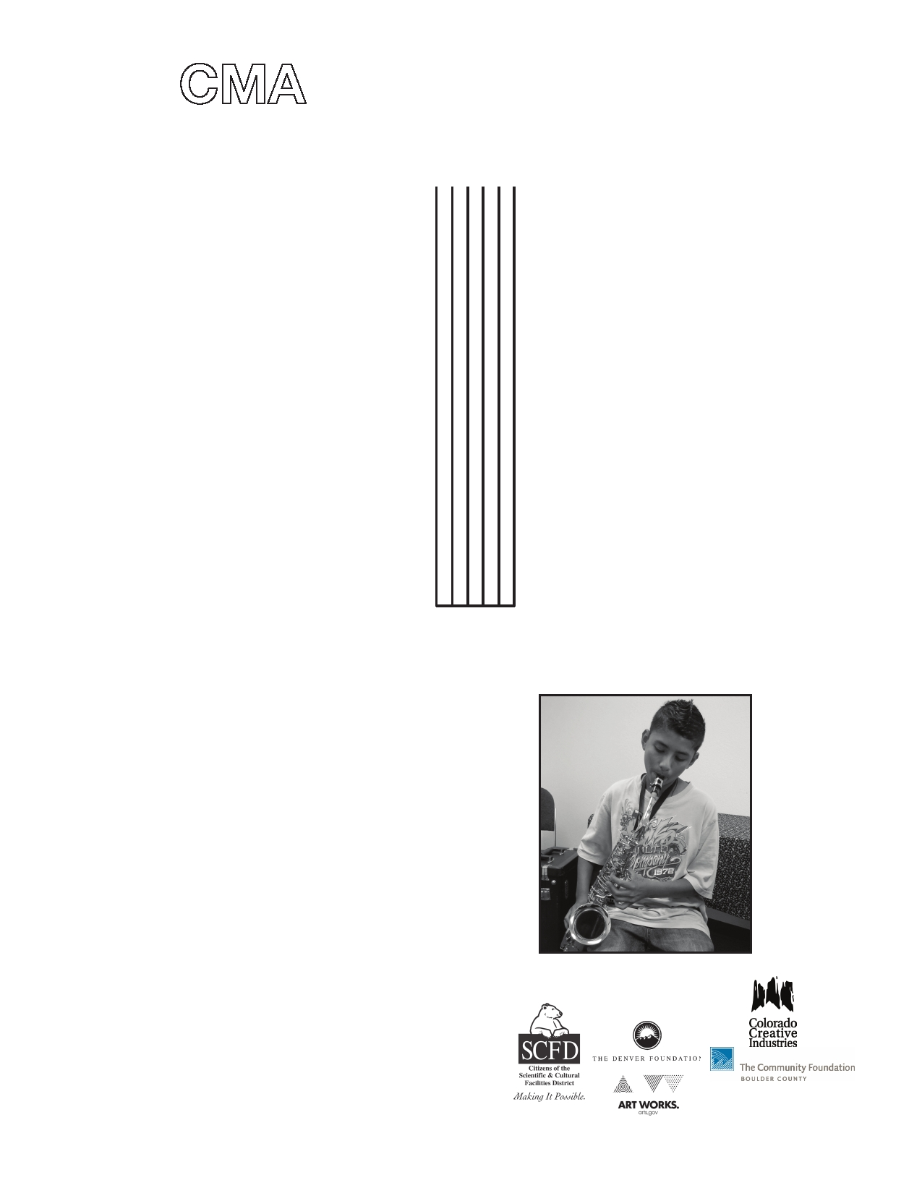CMA instrument bank
Musical Instruments available through the
Center for Musical Arts

The CMA,
a non-profit community
music school, has previously-
used instruments that have been
donated, (woodwinds, strings, brass
and percussion) that are available for a very low monthly fee to any student in the community.

Instruments will be available for
rental on September 11, 2014 from
3-6pm in CMA's Grimes Hall.
Instruments will be assigned on
a first-come-first-served basis.
Please come prepared to sign an
instrument rental agreement form
and arrange a payment plan. If you
cannot come on September 11, call to
make an appointment with Nancy
at 303 665-0599 x100.

Individual lessons are also available on a tuition-assisted basis. Our Heartstrings program of tuition assistance and instrument bank for families in need means that no student will be turned away because of financial need. We will work with students and families to find the best possible payment arrangement.

Don't let
finances get in the way of
learning to play an instrument!

Instruments available for rental
September 11, 2014 3-6pm
or make an appointment at
303 665-0599 x100

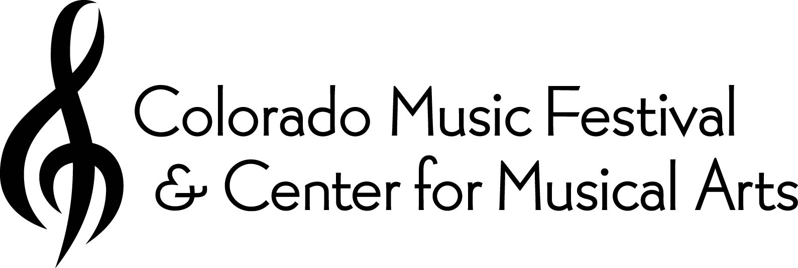General Sponsors:
Boulder Investment Advisors

Xcel Energy Foundation
Sheila Fortune Foundation
200 E Baseline Rd, Lafayette, CO 80026 (one block east of Public Rd., at the corner of Baseline and Harrison) www.comusic.org

