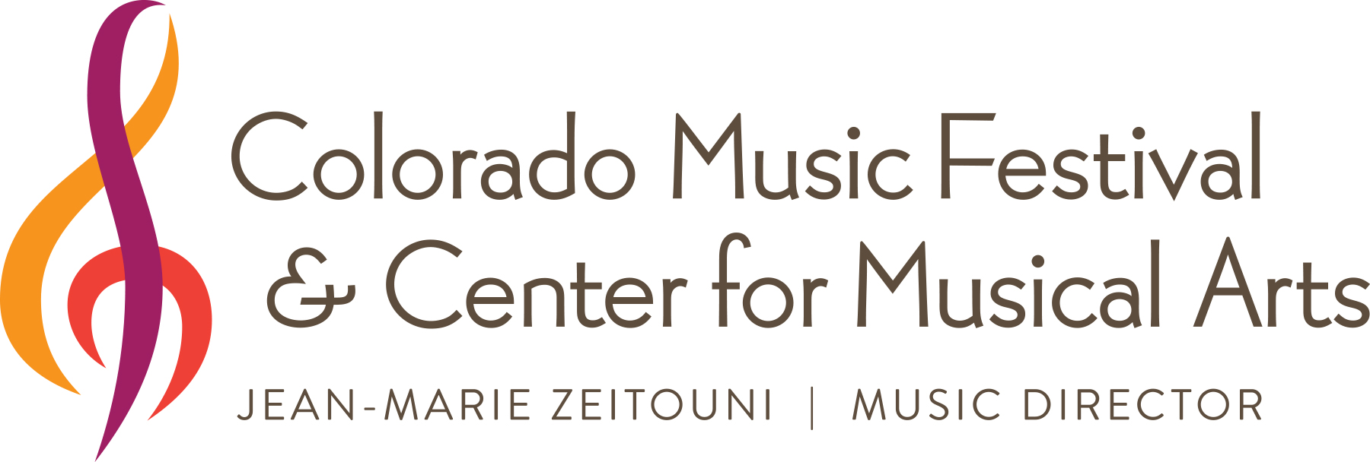
2016 Performathon
Student Fundraiser
Saturday, March 5, CMA 10 am–3 pm

Sponsor Sheet

_____________________________________________

Performer’s Name

SPONSOR’S NAME | PHONE NUMBER | Email Address | PLEDGE  AMOUNT | PAYMENT METHOD  (cash, check, credit card online) | MONEY ENCLOSED  (y/n)
 |  | TOTAL RAISED:

Record all pledges regardless of payment method. Please make checks payable to “CMA”. For credit card payments, visit comusic.org and click the Performathon image on the top right corner. Donations made online will be acknowledged with a formal donation letter.

(Note to performer: bring this sheet/envelope & funds collected to Performathon on March 5.)

