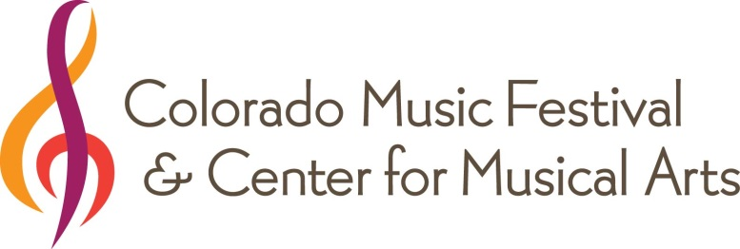

200 E. Baseline Road.

Lafayette, CO 80026

303-665-0599

www.COmusic.org

FOR IMMEDIATE RELEASE MEDIA CONTACT: Cindy Sewell Hohman

303-665-0599, ext 104

High-resolution images available for download. hohman@comusic.org

Colorado Music Festival & Center for Musical Arts welcomes
Time for Three to Boulder for a benefit concert

(Lafayette, Colo.) – December 10, 2014 – The Colorado Music Festival & Center for Musical Arts (CMF & CMA) welcomes the self-proclaimed “classically-trained garage band” Time for Three (Tf3) to Boulder for a benefit concert on Jan. 8, 2015 at 7:30 p.m. at the Boulder Theater.

Time for Three—violinist Zachary (Zach) De Pue, violinist Nicolas (Nick) Kendall and double-bassist Ranaan Meyer—is a group that defies any traditional genre classification, happily and infectiously. With an uncommon mix of virtuosity and showmanship, the American trio performs music from Bach to Brahms and beyond as well as playing originals and their own arrangements of everything from bluegrass and folk tunes to ingenious mash-ups of hits by the Beatles, Kanye West, Katy Perry, Justin Timberlake and more.

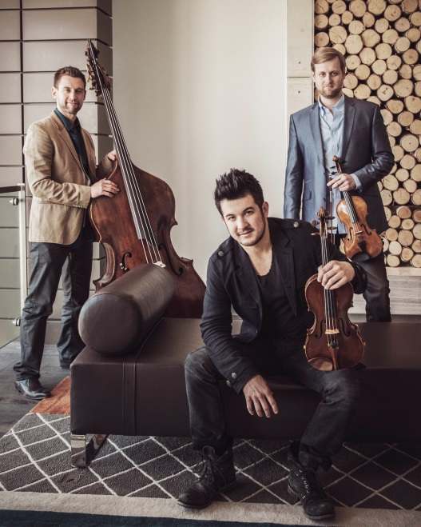
“We are pleased to welcome Time for Three back to Boulder, especially in support of the Colorado Music Festival & Center for Musical Arts. Tf3 has built an incredible fan base in Boulder, packing Chautauqua Auditorium and wowing summer Festival goers, so we are all especially excited to bring this group back for their Boulder Theater debut,” said Andrew Bradford, executive director of CMF & CMA.

Tf3 has performed from Carnegie Hall in New York City and the famed jazz club Yoshi’s in San Francisco to NFL games and the Indy 500. The group garnered buzz this fall with a performance with the Melbourne Symphony Orchestra and an appearance on ABC’s “Dancing with the Stars.”

Individual tickets start at $37 and can be purchased at the Boulder Theater box office at 2032 14th Street, online at www.bouldertheater.com or by calling 303-786-7030.
Credit: LeAnn Mueller

VIP ticket packages are available including a pre-concert dinner, preferred seating, special room rates at Hotel Boulderado and more. For more information on VIP packages, visit www.comusic.org. VIP ticket packages can be purchased by calling 303-665-0599 x109 or emailing romero@comusic.org.

All proceeds from ticket sales will support the Colorado Music Festival & Center for Musical Arts’ artistic, education and community service programs. These programs include the 2015 summer music festival at Boulder’s historic Chautauqua Auditorium, music lessons, low-cost instrument rental and financial aid for families who cannot afford full tuition.

This event is sponsored by Chris and Barbara Christoffersen.

Media Resources
Online press release: www.comusic.org/press-releases/
High-resolution images: www.comusic.org/tf3-photos/
Website: www.comusic.org

The Colorado Music Festival & Center for Musical Arts (CMF & CMA) provides a broad spectrum of music education opportunities and world-class performances to citizens throughout Boulder County and beyond. CMA is located in the heart of downtown Lafayette and features thirteen teaching studios and two performance spaces.. CMF presents a six-week summer concert season at Chautauqua Auditorium in Boulder showcasing the CMF Orchestra. CMF & CMA's mission is to inspire and connect community members of all ages by providing access to the best of the world's music through education and performance.
###

